МИНИАТЮРНЫЕ ТУМБЛЕРЫ
Условное обозначение:  Пример: MTS-102-А 1  MTS - тип  1 - количество контактных групп  О2 - количество контактов в группе  А - варианты рычажка  1 - варианты выводов | Технические характеристики:  Номинальные значения:  10А 125 В / 6А 250 В пер.тока  Контактное сопротивление:  20 МОм макс.  Сопротивление изоляции:  100Mo мин.( 500В пост.тока)  Электрическая прочность диэлектрика:  1500 в пер.тока за1 минуту  Рабочая температура:  от -55 С до 85 С  Электрический ресурс:  20 000 циклов

MTS-101 ON-OFF  SPST 2P | 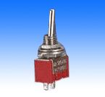 | 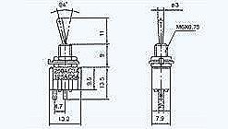

MTS-102 ON-ON  MTS-112 ON-(ON)  MTS-103 ON-OFF-ON  MTS-113 ON-OFF-(ON)  MTS-123 (ON)-OFF-(ON)  SPDT 3P | 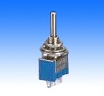 | 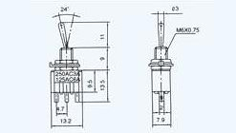

MTS-201 ON-OFF  DPST 4P | 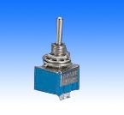 | 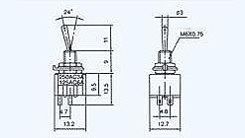

MTS-202 ON-ON  MTS-212 ON-(ON)  MTS-203 ON-OFF-ON  MTS-213 ON-OFF-(ON)  MTS-223 (ON)-OFF-(ON)  DPDT 6P | 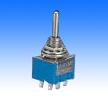 | 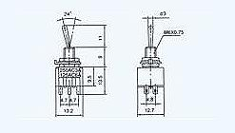

MTS-101-A2 ON-OFF  SPST 2P | 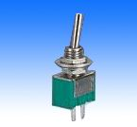 | 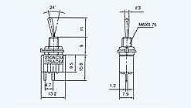

MTS-102-A2 ON-ON  MTS-112-A2 ON-(ON)  MTS-103-A2 ON-OFF-ON  MTS-113 -A2 ON-OFF-(ON)  MTS-123-A2 (ON)-OFF-(ON)  SPDT 3P | 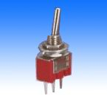 | 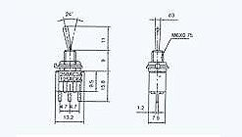

MTS-201-A2 ON-OFF  DPST 4P | 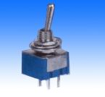 | 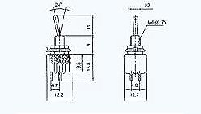

MTS-202-A2 ON-ON  MTS-212-A2 ON-(ON)  MTS-203-A2 ON-OFF-ON  MTS-213 -A2 ON-OFF-(ON)  MTS-223-A2 (ON)-OFF-(ON)  DPDT 6P | 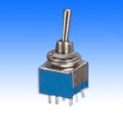 | 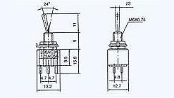

MTS-102-A2T ON-ON  MTS-112-A2T ON-(ON)  MTS-103-A2T ON-OFF-ON  MTS-113 -A2T ON-OFF-(ON)  MTS-123-A2T (ON)-OFF-(ON)  SPDT 3P | 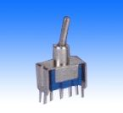 | 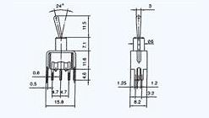

MTS-202-A2T ON-ON  MTS-212-A2T ON-(ON)  MTS-203-A2T ON-OFF-ON  MTS-213 -A2T ON-OFF-(ON)  MTS-223-A2T (ON)-OFF-(ON)  DPDT 6P | 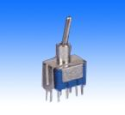 | 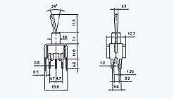

MTS-102-C3 ON-ON  MTS-112-C3 ON-(ON)  MTS-103-C3 ON-OFF-ON  MTS-113 -C3 ON-OFF-(ON)  MTS-123-C3 (ON)-OFF-(ON)  SPDT 3P | 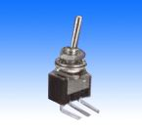 | 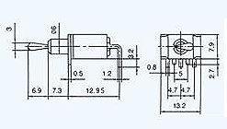

MTS-202-C3 ON-ON  MTS-212-C3 ON-(ON)  MTS-203-C3 ON-OFF-ON  MTS-213 -C3 ON-OFF-(ON)  MTS-223-C3 (ON)-OFF-(ON)  SPDT 6P | 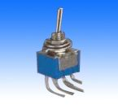 | 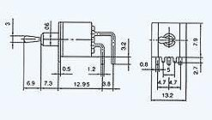

MTS-102-C4 ON-ON  MTS-112-C4 ON-(ON)  MTS-103-C4 ON-OFF-ON  MTS-113 -C4 ON-OFF-(ON)  MTS-123-C4 (ON)-OFF-(ON)  SPDT 3P | 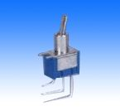 | 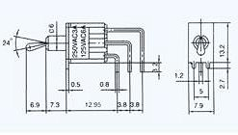

MTS-202-C4 ON-ON  MTS-212-C4 ON-(ON)  MTS-203-C4 ON-OFF-ON  MTS-213 -C4 ON-OFF-(ON)  MTS-223-C4 (ON)-OFF-(ON)  DPDT 6P | 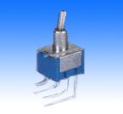 | 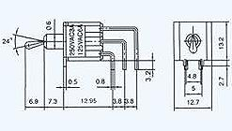

MTS-101-E1 ON-OFF  SPST 2P  (PLASTIC FLATLEVER) | 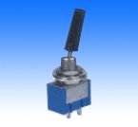 | 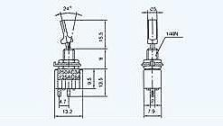

MTS-102-E1 ON-ON  MTS-112-E1 ON-(ON)  MTS-103-E1 ON-OFF-ON  MTS-113 -E1 ON-OFF-(ON)  MTS-123-E1 (ON)-OFF-(ON)  SPDT 3P  (PLASTIC FLATLEVER) | 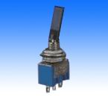 | 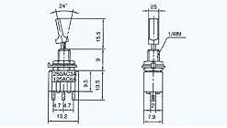

MTS-202-E1 ON-ON  MTS-212-E1 ON-(ON)  MTS-203-E1 ON-OFF-ON  MTS-213 -E1 ON-OFF-(ON)  MTS-223-E1 (ON)-OFF-(ON)  DPDT 6P  (PLASTIC FLATLEVER) | 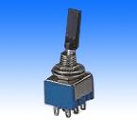 | 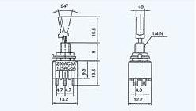

MTS-101-F1 ON-OFF  SPST 2P  (METAL FLATLEVER) | 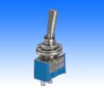 | 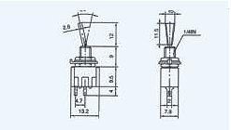

MTS-102-F1 ON-ON  MTS-112-F1 ON-(ON)  MTS-103-F1 ON-OFF-ON  MTS-113 -F1 ON-OFF-(ON)  MTS-123-F1 (ON)-OFF-(ON)  SPDT 3P  (METAL FLATLEVER) | 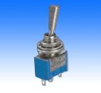 | 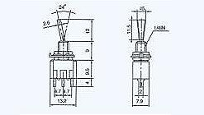

MTS-202-F1 ON-ON  MTS-212-F1 ON-(ON)  MTS-203-F1 ON-OFF-ON  MTS-213 -F1 ON-OFF- (ON)  MTS-223-F1 (ON)-OFF- (ON)  DPDT 6P  (METAL FLATLEVER) | 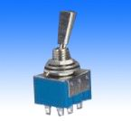 | 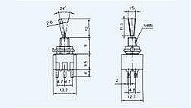

KNX-1 ON-ON  KNX-103 ON-OFF-ON  SPDT 3P | 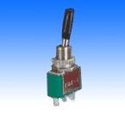 | 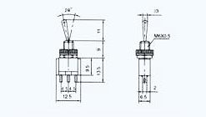

KNX-2 ON-ON  KNX-203 ON-OFF-ON  DPDT 6P | 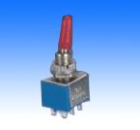 | 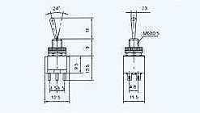

STM-101 ON-OFF  SPST 2P | 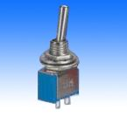 | 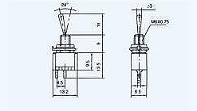

STM-102 ON-ON  STM-112 ON-(ON)  STM-103 ON-OFF-ON  STM-113 ON-OFF-(ON)  STM-123 (ON)-OFF-(ON)  SPDT 3P | 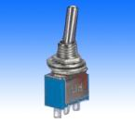 | 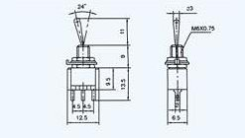

STM-202 ON-ON  STM-212 ON-(ON)  STM-203 ON-OFF-ON  STM-213 ON-OFF-(ON)  STM-223 (ON)-OFF-(ON)  DPDT 6P | 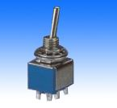 | 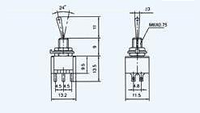

MTS-101 ON-OFF  SPST 2P | 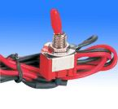 | 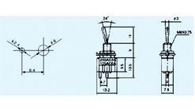

STM-202-A3 ON-ON  STM-212-A3 ON-(ON)  STM-203-A3 ON-OFF-ON  STM-213-A3 ON-OFF-(ON)  STM-223-A3 (ON)-OFF-(ON)  DPDT 6P | 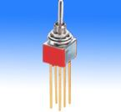 | 